WEBSITE REQUIREMENTS SPECIFICATION

[Travelling website DANADULI.COM]

Created by [Huy Pham]

Version 1.0 - Issued September 7th, 2019

This requirements specification is used to record the user requirements for a website.

*Da Nang, Sep-7th-2019*

**BACKGROUND**

Nowaday, the number of tourists coming to Da Nang is increasing. But normally, they often visit to the famous places to take a photo then they leave. Actually, they don’t really know and understand the historical and culture informations of the place where they are visitting. It makes the beauty of Da Nang is known as the objects but no historical and culture informations.

**RECORD OF CHANGE**

|  |  |  |  |  |
| --- | --- | --- | --- | --- |
| Effective Day | Change Items | A, M, D (*) | Change Description | New Version |
| Sep-7th-2019 |  |  | First created | 1.0 |
|  |  |  |  |  |
|  |  |  |  |  |
|  |  |  |  |  |
|  |  |  |  |  |
|  |  |  |  |  |

**SIGNATURE PAGE**

**TEAM MEMBERS**

Phạm Văn Huy Sep-16th-2019 ______________

Trần Ngọc Thái Sơn Sep-16th-2019 ______________

Lê Trần Quý Nhân Sep-16th-2019 ______________

Nguyễn Thị Tuyển Sep-16th-2019 ______________

Nguyễn Thị Thảo Sep-16th-2019 ______________

Trương Thị Thu Lợi Sep-16th-2019 ______________

Lê Thị Mai Lan Sep-16th-2019 ______________

Nguyễn Thị Sương Sep-16th-2019 ______________

**REVIEWER AND APPROVAL**

Cao Thị Nhâm Sep-16th-2019 ______________

**TABLE OF CONTENTS**

**1 Introduction 5**

**1.1 Purpose 5**

**1.2 Scope 5**

**2 Website Description 6**

**2.1 Visitor Interaction 6**

**2.1.1 Tương tác của khách truy cập 6**

**2.1.2 Khả năng truy cập 6**

**2.2 Editing, Updates and Administration 7**

**2.2.1 Administrative function 7**

**2.3 Sitemap and Navigation 8**

**2.4 Content Management 9**

**2.5 Website statistics 9**

**2.6 Search Engine Optimisation 9**

**2.7 Security 10**

**2.8 Hosting 10**

**2.9 Maintenance and Support 10**

**2.10 Considerations 10**

**2.11 Assumptions 10**

# Introduction

## Purpose

This document provides a comprehensive descriptions of DANADULI.COM WEBSITE PROJECT.

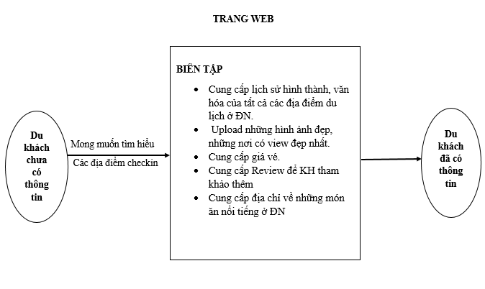

## Scope

This document is applied for DANADULI.COM TRAVELLING WEBSITE PROJECT and used to manage effort spent in website development.

# Website Description

## Visitor Interaction

### Interactions of visitors

* Visitor clicks on any link on webpage.
* Người dùng chat với chatbot trên website DANADULI.COM
* Visitor clicks on media files.
* Người dùng nhấn like fanpage Facebook tích hợp trên website
* Visitor clicks on any link to access minor webpage.
* Using legible fonts.
* Increasing the number of internal links on homepage.
* Optimize the layouts of website.
* Tích hợp Chat trực tuyến
* Dùng ngôn ngữ nói cho [các lời chào](https://subiz.com/blog/tai-sao-phai-chao-hoi-khach-hang-ghe-tham-website.html)
* Tạo ra ngữ cảnh chat phù hợp cho từng đối tượng khách hàng

### Accessibility

* Increasing the accessibility on Facebook fanpage to let visiors reach the website.
* Avoiding irrelevant contents.
* Using actual informations of Danang
* Using clearly contents, informations.
* Using reviews and informations of visitors experienced.

## Editing, Updates and Administration

### Administrative function

#### Logging in

The administration website: danaduli.com/wp-admin

Account and password (as sign up at the first time)

#### Forgotten user name and password

In case the admin forgets the user name and password, he can find it out in the email which Wordpress has sent at the beginning when creating website danaduli.com

#### Changing logging in informations

Admin can change the password in User Account tab in MyPhpAdmin box.

#### Modifying website

Admin can create, edit, delete and restore posts on danaduli.com easily. Also, admin can create new pages with contents which are need to provide to tourists.

## Sitemap and Navigation

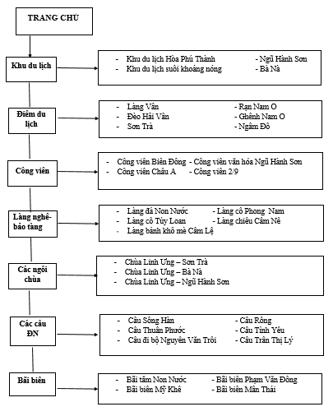

## Content Management

|  |  |  |
| --- | --- | --- |
| Req | Description | Comments |
| 2.4.1 | Historical and culture informations | Providing informations |
| 2.4.2 | Beautiful background | Tourists can take photos in these backgrounds |
| 2.4.3 | Ticket price | Ticket price in every place provided. |
| 2.4.4 | Reviews | Reviews from tourists who have visitted. |

## Website statistics

Using Google Analytics plug-in.

This Google Analytics for WordPress plugin enables you to track your site using the latest Google Analytics tracking code and allows you to view key Google Analytics stats in your WordPress install.

In addition to a set of general Google Analytics stats, in-depth Page reports and in-depth Post reports allow further segmentation of your analytics data, providing performance details for each post or page from your website.

The Google Analytics tracking code is fully customizable through options and hooks, allowing advanced data collection like custom dimensions and events.

## Search Engine

Using Ivory Search – Wordpress Search plug-in.

Ivory Search is a simple to use advanced WordPress search plugin. It enhances the default WordPress search and also allows you to create new custom search forms.

With Ivory Search, tourists can create an unlimited number of search forms and configure each search form individually to customize WordPress search and perform different types of searches on site content.

## Security

|  |  |  |
| --- | --- | --- |
| Req | Description | Comments |
| 2.7.1 | Protect wp-admin folder | Using Better WP Security plug-in to change the default address of wp-admin folder |
| 2.7.2 | Protect plug-in folders | Creating a new index.html file then downloading it to the address  /wp-content/plugins |
| 2.7.3 | Changing log in account name | Creating a new administrator user then deleting the old admin user |
| 2.7.4 | Protect data | Backup website’s data. |

## Hosting

Using local host.

## Maintenance and Support

Using WP Maintenance Mode plug-in.

When our website has problem or update new features then we have to maintain our website. While maintaining, a notification window will be shown on the tourists screen.

## Considerations

* Designing homepage arrangement.
* Styling website contents.

## Assumptions

* Wordpress platform. Our website developement based on Wordpress platform.
* Wordpress plug-in. The functions are mentioned using Wordpress plug-in.